**Chapter 2: CENTRAL TENDENCY & PICTOGRAM**

**Topic – 1: Types Of Graphs**

**Multiple Bar Chart**

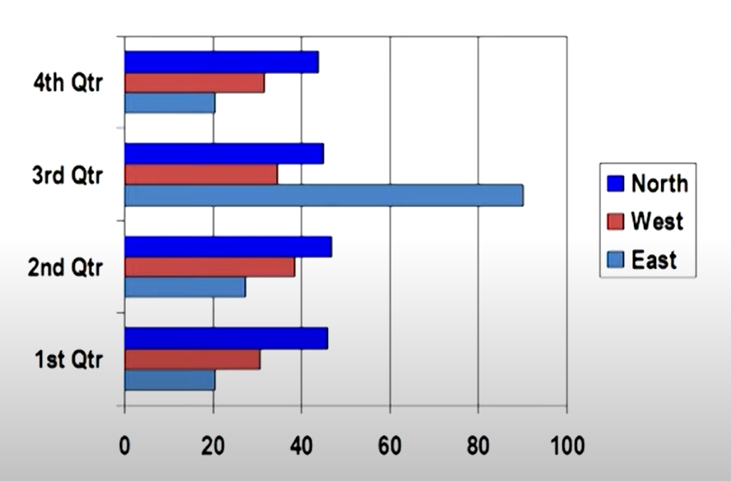

**Simple Pictograph**

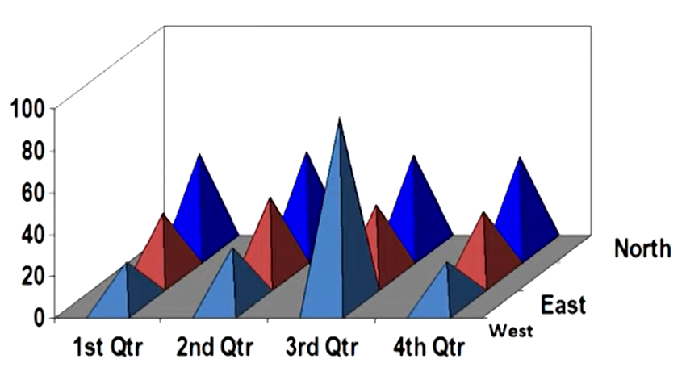

**Histogram**

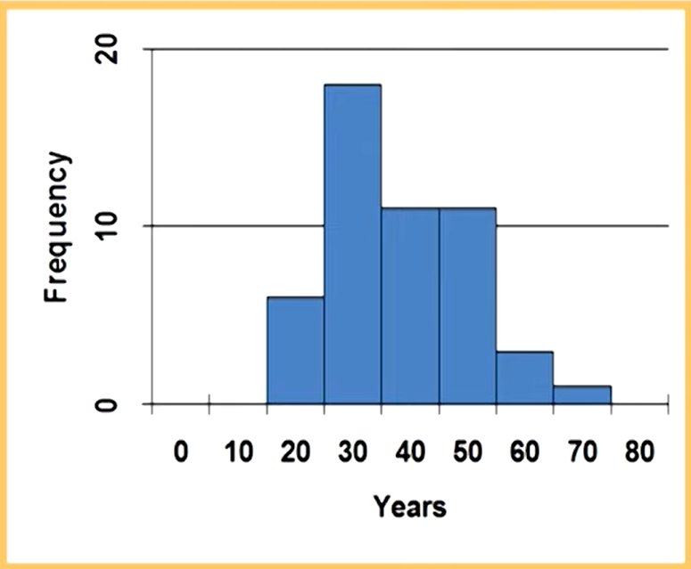

**Frequency Polygon**

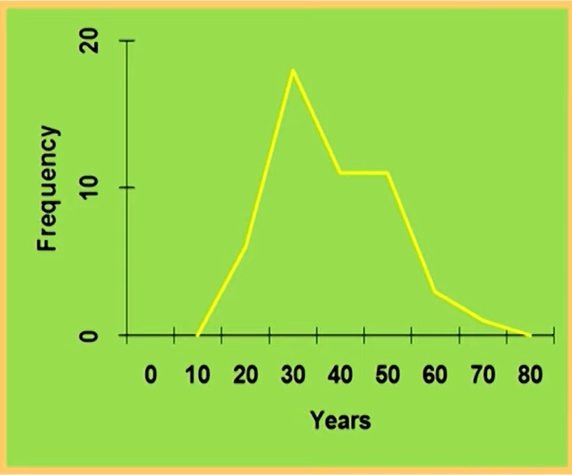

**Ogive**

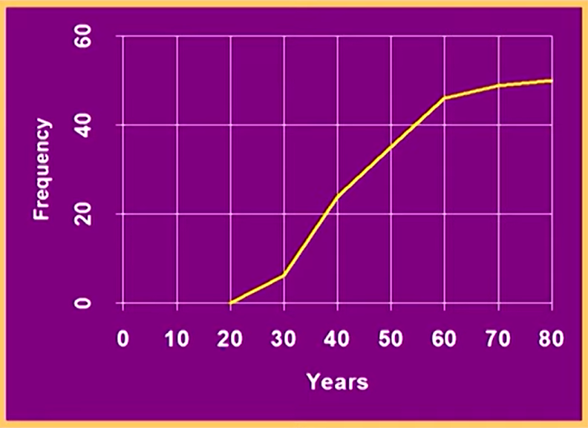

**Pareto Chart**

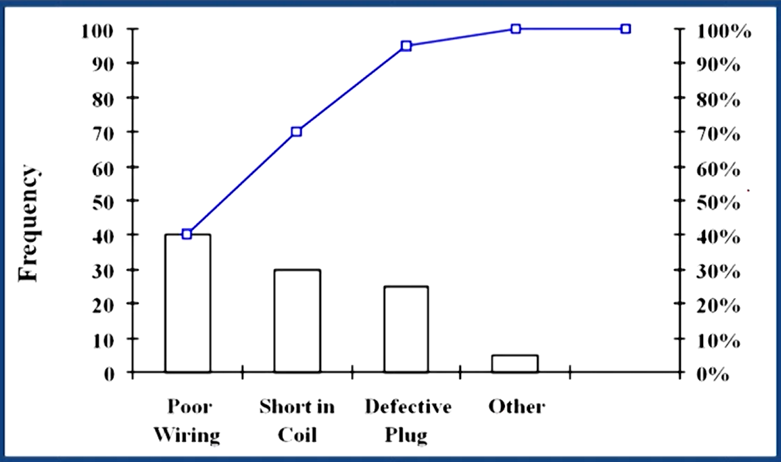

**Topic – 2: Central Tendency**

**Measures Of Central Tendency**

* A particular number representing a **group of values**.
* Also known as ***measure of locations***.

**Types Of Central Tendencies**

* Arithmetic mean
* Weighted mean
* Median
* Percentile

**Arithmetic Mean**

* Applicable only on **interval** & **ratio** data.

**Population Mean**

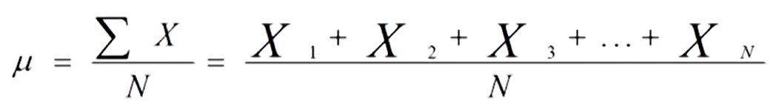

**Sample Mean**

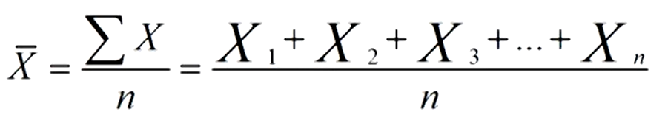

**Mean Of Grouped Data**

* **Grouped data:** Data given in form of table.
* Weighted average of class midpoint.
* **Class midpoint:** Average of **upper limit** & **lower limit** of range class.
* **Weight:** Class frequencies.

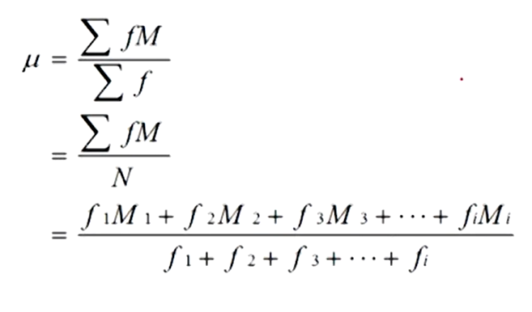

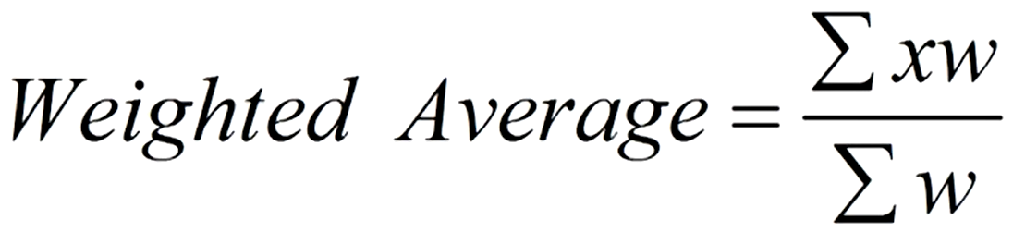

**Example (Mean Of Grouped Data)**

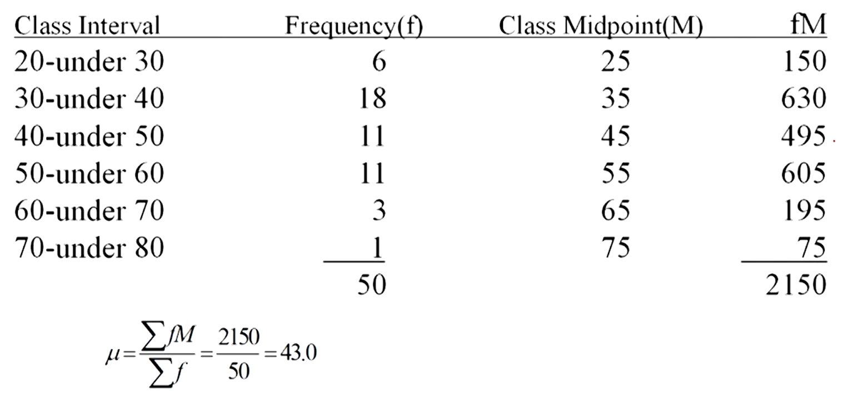

**Median**

* Applicable only on **ordinal**, **interval** & **ratio** data.
* Unaffected by **outliers**.

**Median Of Grouped Data**

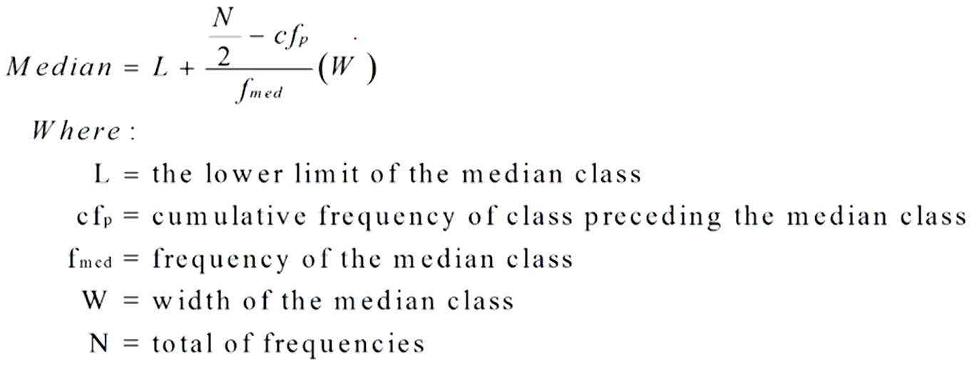

**Example (Median Of Grouped Data)**

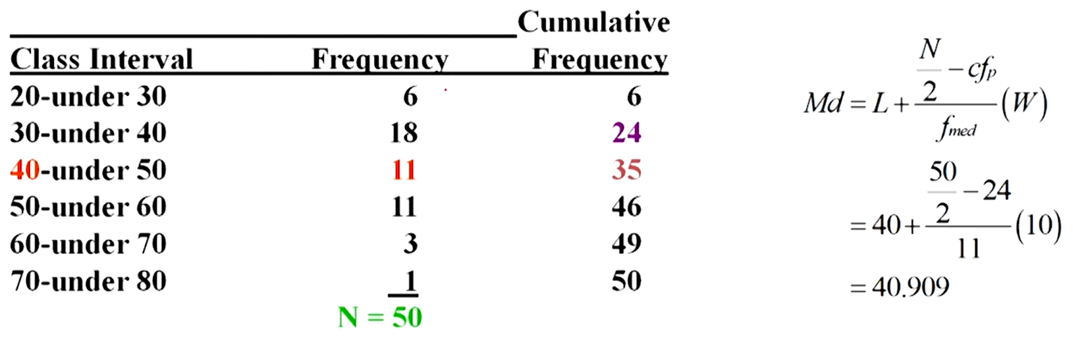

* ***w*** here is the **difference** between **upper** & **lower limit** of class.

**Mode**

* Applicable to all **nominal**, **ordinal**, **interval** & **ratio**.
* **Bimodal:** Datasets with **two modes**.
* **Multimodal:** Datasets with **multiple modes**.

**Mode Of Grouped Data**

* **Modal class** has **highest** frequency value.

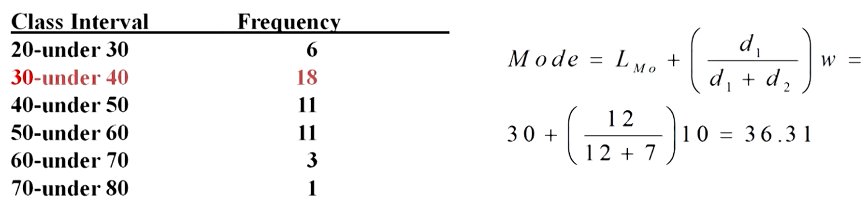

* ***d1*** is the frequency difference between **modal class** & **preceding class**.
* ***d2*** is the frequency difference between **modal class** & **next class**.

**Percentiles**

* Applicable only on **ordinal**, **interval** & **ratio** data.
* **Median** & **50th percentile** have same value.

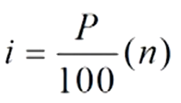

* ***i*** represents **position** of the value.
* If ***i*** is a **whole number**, then the **percentile P** is average of ***i*** & ***(i+1)***.
* If ***i*** is **not** a **whole number**, then the **percentile P** is ***(i+1)***.

**Topic – 3: Dispersion**

**Introduction**

* **Dispersion:** **Variability** of measure of central tendency.

**Common Measures Of Variability**

* Range
* Inter-quartile range
* Mean absolute deviation
* Variance
* Standard deviation
* Z scores
* Coefficient of variation

**Range (Ungrouped Data)**

* Difference between **smallest** & **largest value** in a given dataset.

**Quartiles**

* Division of data into **4 sub-groups**.

**1st quartile Q1 = 25 percentile (25% of dataset)**

**2nd quartile Q1 = 50 percentile (50% of dataset)**

**3rd quartile Q1 = 75 percentile (75% of dataset)**

* **Quartile** values **aren’t** necessarily part of the dataset.
* Put value of **P** accordingly to get results as per **quartile values**.

**Interquartile Range**

* Range of values between **1st** and **3rd quartiles**.
* Also known as ***range of middle-half***.
* **Not** much influenced by **extreme values**.

**Interquartile range = Q3 – Q1**

**Deviation From Mean**

**Deviation from mean = Value – x**

**Mean Absolute Deviation**

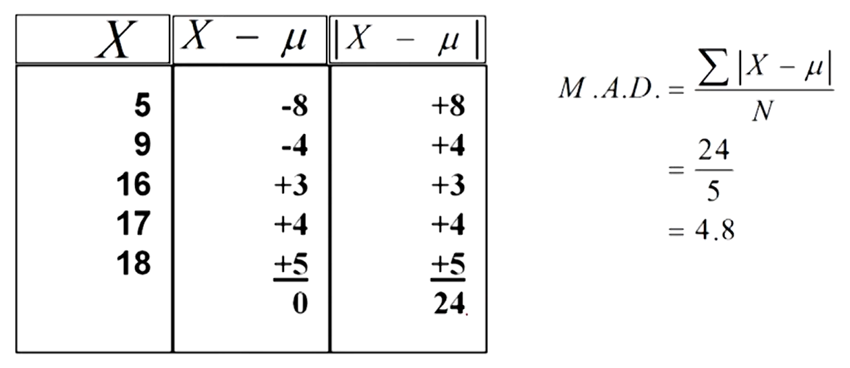

**Population Variance**

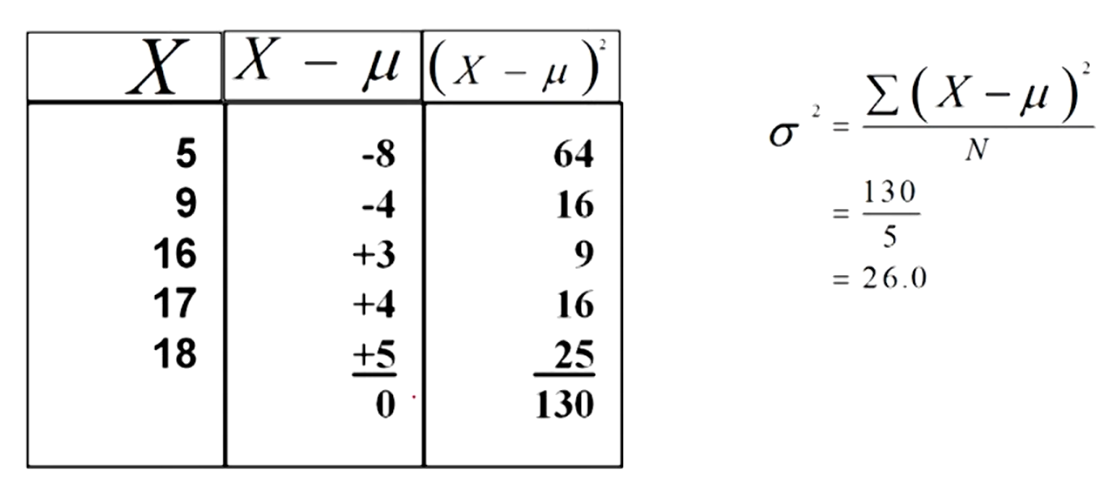

**Sample Variance**

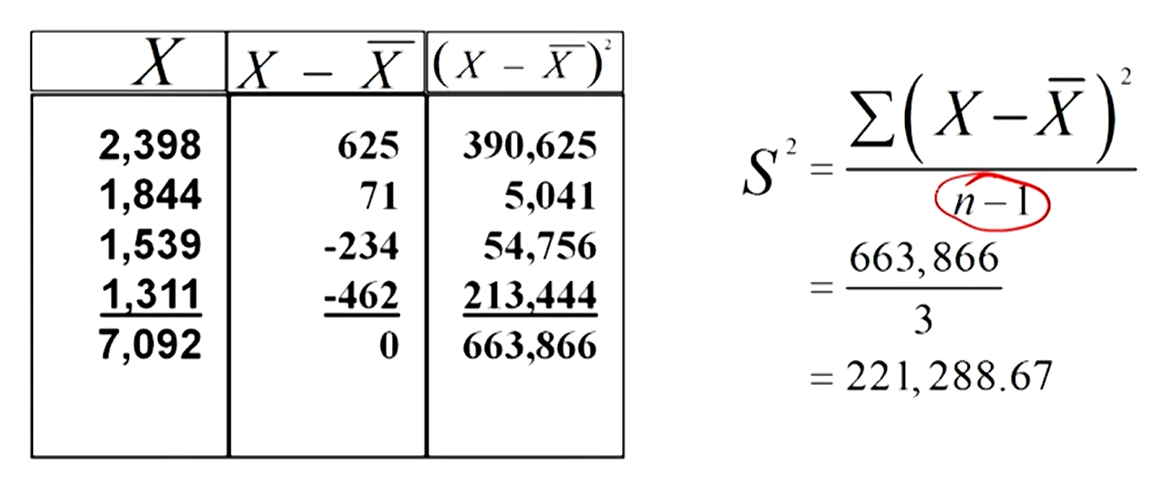

**Sample Standard Deviation**

* Square root of sample variance.

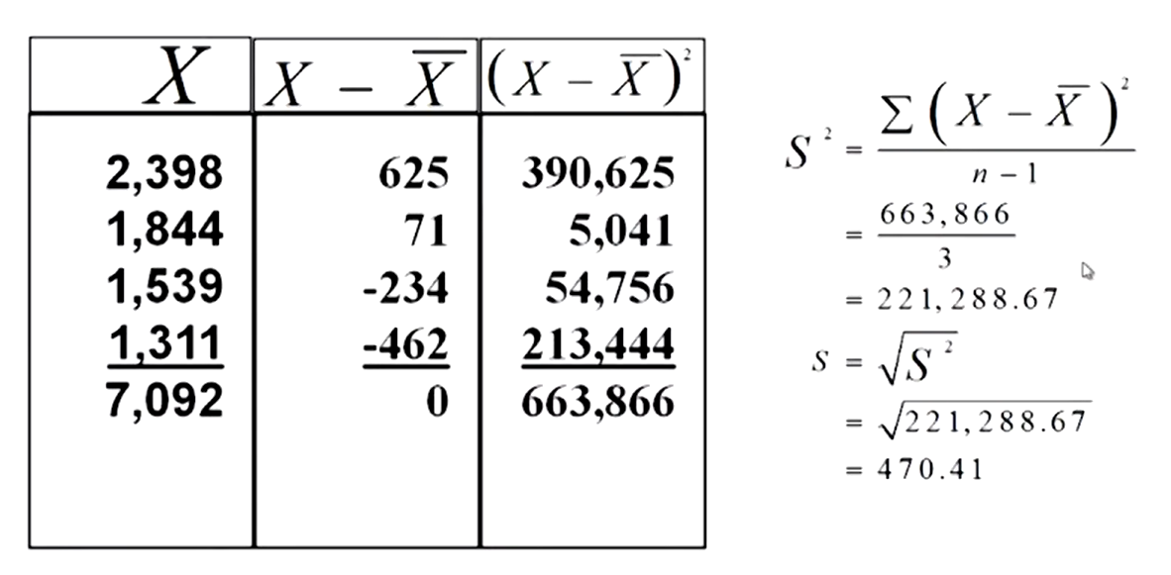

**Uses Of Standard Deviation**

* Indicator of **financial risk**, less the **standard deviation** the less the risk.
* **Quality control**, the less the **variance** the better the quality of product.
* **Comparing population** etc.